RT-25035/07 /2023-RS (Part) (221534)

**Government of India**

Ministry of Road Transport & Highways (Road Safety Cell)

Transport Bhawan, 1 Parliament Street, New Delhi-110001

Dated: 20th July, 2023

**To,**

1. The Chief Secretaries of all the State Governments/UTs.
2. The Principal Secretaries/ Secretaries of all States/ UTs Public Works Department dealing with National Highways, other centrally sponsored schemes.
3. All Engineers-in-Chief and Chief Engineers of Public Works Department of States/ UTs dealing with National Highways, other centrally sponsored schemes.
4. The Director General (Border Roads), Seema Sadak Bhawan, Ring Road, New Delhi -110010.
5. The Chairman, National Highways Authority of India, G-5 & 6, Sector-10, Dwarka, New Delhi - 110075.
6. The Managing Director, NHIDCL, PTI Building, New Delhi-110001.
7. All CE-ROs, ROs and ELOs of the Ministry.
8. The Secretary General, Indian Road Congress - to incorporate the guidelines in respective IRC Codes simultaneously

**Subject: Guidelines for provision of signages on Expressways and National Highways-reg.**

Madam/Sir,

Road signages and markings play a critical role in ensuring the safety of all road users. To maintain value added services, signages should be used to provide guidance, warnings, notice and regulatory information to road users in well­ designed formats for ensuring comfortable, safe, uniform and efficient operations.

1. A committee had been setup by Ministry to review the provision of signages as per relevant IRC Codes & guidelines, existing practices prescribed in various international codes, information and functionality perspective to ensure better compliance of traffic regulations. Based on the recommendations of the Committee, the Hon'ble Minister, RT&H has approved the **Guidelines for provision of signages on Expressways (Appendix-A)** and **Guidelines for provision of signages on National Highways (Appendix-B)** for implementation on priority.
2. Accordingly, these guidelines should be implemented on all road categories of National Highways and Expressways on priority basis to have uniformity. In the

first stage, it should be implemented on all new upcoming Highways, Expressways and Greenfield Corridors along with Highways having PCU's more than 20,000 and the cost implication on·per kilometer basis should be worked out simultaneously.

1. These guidelines shall supersede all related codal provisions/guidelines issued in this regard.
2. This issues with the approval of the Competent Authority.

Yours faithfully,

**Encl: As above**

**(Gau av H. upta) Director (Road Safety)** Email: [gaurav.gupta@gov.in](mailto:gaurav.gupta@gov.in)

**Copy to:**

* 1. All ADGs and CEs in the Ministry of Road Transport a Highways
  2. Director (MVL), MoRTH
  3. NIC - for uploading on Ministry's website under "What's new

**Copy for information to:-**

1. PS to Hon'ble Minister, RT&H
2. PS to Hon'ble MoS, RT&H
3. Sr. PPS to Secretary, RT&H
4. PS to AS (Highways), MoRTH
5. PS to AS (Road Safety), MoRTH
6. Sh. V.K. Rajawat, ADG (Road Safety), MoRTH
7. Sh. Manoj Kumar, Member (Projects), NHAI
8. Sh. Ajmer Singh, CE, MoRTH
9. Smt. Geetam Tiwari, Professor, IIT Delhi

##### Appendix-A

(Letter No. RT-25035/07 /2023-RS(Part) dated 2,QJuly, 2023)

**Guidelines for provision of signages on Expressways**

## General

To maintain value added services, signs should be used to provide guidance, warnings, notice and regulatory information to road in well-designed formats for ensuring comfortable, safe and smooth driving.

Signs provide information on entry/exit directions, destinations and points of interest. Signs are designed so that they are legible to road users approaching them and readable in time to permit proper responses. Desired design characteristics include:

* long visibility distances,
* large lettering and symbols, and
* Short legends for quick comprehension

In general, the road signage shall follow IRC: 67 Code of practice for road signs, IRC: 35 Code of Practice for Road Markings and Clause 800: traffic signs, markings and other appurtenances in MORTH - Specifications for road and bridge works. In addition, now certain provisions are included in this guideline for better visibility and understanding of the road users on Expressway which shall supersede all CodaI provisions/guidelines issued till date in respect of these provisions and must be followed in addition to all other provisions of IRC: 67, IRC: 35 and Clause 800 etc.

Functionally road signages are classified as follows:

* Mandatory/Regulatory signs
* Cautionary/ Warning signs
* Informatory/Guide signs

## Mandatory/ Regulatory Signs

These signs are used to impose legal restrictions applicable to certain particular locations. These include all signs, such as, Speed limits, No Entry, etc. which give notice of special obligations, prohibitions or restrictions for traffic control. The violation of the rules and regulations conveyed by these signs is a legal offence and shall attract penalty.

#### Size and Dimension of Mandatory Signs

*Table 1: Size and Dimension of Mandatory Sign*

|  |  |  |  |
| --- | --- | --- | --- |
| Design Speed | Diameter (mm) | Border (mm) | Oblique Bar (mm) |
| 81-120 kmph | 1200 | 100 | 100 |
| 121-150 kmph | 1500 | 125 | 125 |

*Oblique Bar will come to indicate in prohibition

* 1. Mandatory Signs to be installed
     1. No Parking

No Parking sign is used to prevent any parking of vehicles on the main carriageway which will lead to congestion. It is to be provided at an interval of every 5 km **(Fig. 2.1)**

* + 1. Speed Limit Sign Board

Speed limit sign board is provided to warn the drivers about the maximum speed limit at which they can drive vehicle. Since the speed limit is different for car, bus and trucks the sign board **(Fig. 2.2)** and gantry **(Fig. 2.3)** has been introduced. Where different speed limits are to be imposed on certain classes of vehicle types this shall be specified separately to ensure that the numerals indicating the speed limit are clearly visible from a distance. Symbol of specific vehicle type shall accompany such speed limit indication **(Fig. 2.2).** The speed limit sign Board should be repeated at every 5 km alternately on shoulder side and median side. The size of sign board shall be 1800 X 3000mm in which the diameter of circle shall be as per Table-1.

* + 1. Speed Gantry:

Vehicle Category wise and speed wise lane dedicated information signs is to be installed on high-speed corridors at an interval of 20kms as an overhead gantry **(Fig.2.3).**

* + 1. **Height** Limit **Sign** Board:

If the height of superstructure over bridges/underpass structures exceeds 5.Sm no board is required, but if it is less than 5.Sm then Height Limit Sign board of appropriate limit is to be provided **(Fig. 2.4).**

# Cautionary/ Warning Signs

These signs are used to call attention to actual or potentially hazardous conditions, so that the users can become cautious and take the desired action.

The signs shall be in the shape of an equilateral triangle, with apex pointing upwards. It shall have red border and black symbols on white background.

* 1. Size and Dimension of Cautionary Signs

The size and siting details shall be as per Table 3.1.

*Table 2: Size and Dimension of Cautionary Sign*

|  |  |  |  |
| --- | --- | --- | --- |
| Design Speed | Diameter (mm) | Border (mm) | Distance of Sign from Hazard (mm) |
| 81-120 kmph | 1200 | 90 | 180-245 |
| 121-150 kmph | 1500 | 110 | 245-305 |

* 1. Cautionary Sign to be installed
     1. Left-Hand and Right-Hand Curve

If the difference between the approach speed to a curve and the safe negotiating speed derived based on geometric parameters of curve exceeds 15 Kmph, the curve



shall be provided with Left-hand curve and Right-hand curve warning sign boards. **{Fig.**

##### 3.1}

* + 1. Merging Traffic Ahead

This sign is posted in situations where the traffic from other road/ entry ramps is merging with the traffic of main carriageway, and the drivers are required to slow down their vehicles for safe travel **(Fig. 3.2).**

* + 1. Overhead Cables

This sign is used to caution the driver of the presence of overhead power transmission lines **{Fig. 3.3).**

* + 1. Pedestrian Crossing

The sign should be erected in advance on both approaches to uncontrolled pedestrian crossings **{Fig. 3.4).**

* + 1. Reduced **Carriageway**

This sign is used to caution the driver of the reduction in the width of the carriageway ahead **(Fig. 3.5).**

* + 1. Rumble Strip

The sign should be posted at a minimum distance of 50 to 60 min advance of the rumble strips provided on the road to control and reduce the speed. This is to warn the drivers of the presence of the rumble strips **(Fig. 3.6).**

1. Informatory Signs

These signs are used to provide directions to motorists, including route designations, destinations, available services, points of interest, and other geographic, recreational, or cultural sites. These also inform drivers of traffic regulations and information on the points necessary for traffic operation.

#### Size and Dimension of Informatory Signs

|  |  |  |  |  |  |
| --- | --- | --- | --- | --- | --- |
|  | Overhead Direction Signs | | Flag Type Direction Signs | |  |
| Design Speed | Text Height  Lower Case (mm) | Text Height Upper Case  (mm) | Text Height  Lower Case (mm) | Text Height  Upper Case (mm) | Text Thickness (mm) |
| 101-120 | 330 | 460 | 245 | 345 | 50 -Lower Case  60- Upper Case |
| 121-150 | 380 | 530 | 270 | 380 |

*Font Type: Transport Medium

#### Informative Sign to be Installed

* + 1. Reassurance Sign

This sign is installed to reassure a driver of a vehicle that the desired direction is being followed. However, according to IRC:67 and IRC: SP: 99, this sign is shoulder mounted but for better visibility it is converted to full Overhead Gantry **(Fig. 4.1).**



* To be provided after 150-200m of Entry Slip and repeated after every 10 km
* The first two destinations shall be the next two exit and the last shall be the ultimate destination
* The distance of location mentioned on sign board should be the distance of the railway station of that location from the board
* Every alternate or 20th km Reassurance Sign shall be in English and Regional/local language wherever applicable
  + 1. Welcome and Thank-You Gantry

Welcome and Thank You sign board should be installed in first and last package of the project to ensure the road user about the start of expressway so that the restrictions pertaining the project are being followed **{Fig. 4.2 and Fig. 4.3).**

* + 1. Advance Direction Sign

Advance Direction signs shall be used for grade separated Entry and Exit to the expressways. These signs should be placed normally at 500 m, 1 km and at 2 km in advance of the exit. As per IRC:67 the Advance Direction Sign can be gantry or shoulder mounted. For better visibility at high speed, a full overhead gantry shall be provided for Advance Direction Sign Board placed at 2 km before exit **{Fig. 4.4)** and cantilever gantry for Advance Direction Sign Board shall be placed at 500 m and 1 km before exit

**{Fig. 4.5 and Fig. 4.6).** Cantilever gantry should be provided at tapering of Exit ramp

**{Fig. 4.7),** in case of cloverleaf exit sign board shown in **{Fig. 4.8)** should be used. The text in Expressways shall in in Uppercase, whereas for Access Controlled National Highways it should be Sentence case. Cantilever Gantry at 1km before exit should be in Regional and English Language. Typical Advance Direction Sign arrangement for Diamond Interchange is shown in **Fig. 4.9 and** Typical Advance Direction Sign arrangement at Nosing of Cloverleaf Interchange is shown in **Fig 4.10.**

* + 1. Rest and Service Area Sign Board

This sign board is to be provided to inform the road user about the upcoming Way­ Side amenity. It is necessary to alert the driver about the existence of way side amenities by providing cantilever gantry type sign board 5 km ahead with repeater sign at 2 km, 1 km and 500 m ahead and flag type shoulder mounted sign board at the exit nosing for way side amenity. Also, the Rest and Service Area sign board 1 km

before the wayside amenity should be in Hindi i.e., fctl!,lll'.f JfR 00 and at 2 km

before wayside amenity it should in regional language. The dimension of facility sign (logo) shall be 1200 X 900 mm and dimension of sign board shall be 4100 X 3000 mm. The Text height should be 460mm. **(Fig. 4.11 and Fig. 4.12).**

* + 1. Emergency Helpline Number

The Emergency Helpline number "1033" should be provided at every 5km interval dimension 2400 X 1800 mm **(Fig. 4.13).**

* + 1. Heavy Vehicle Keep Left

This sign board is to be provided to inform the drivers of heavy vehicles like trucks moving at lesser speed to drive on left side so that the vehicles moving at higher speed can easily overtake them. The sign board should be provided at an interval of 5 km. dimension 2400 X 2400 mm **(Fig. 4.14).**

* + 1. Expressway and Expressway End Sign

To inform the user about start and end of Expressway, Expressway Sign and Expressway End Sign should be provided in first and last Package of the Project. Dimension 900 X 900 mm **(Fig. 4.15).**

* + 1. Exit and Entry Ramp Sign

Expressway Entry Ramp and Expressway Exit Ramp Sign Board Should be provided at the nosing of Entry and Exit Ramp respectively. Dimension 900 X 900 mm **(Fig. 4.16).**

* + 1. Emergency Call Box

This sign shall be used at regular intervals in rural highways and in tunnel roads where emergency phones are installed. Sign Board should be installed 500m ahead of Emergency Call Box. Dimension 1200 X 900 mm **(Fig. 4.17).**

* + 1. Fee Plaza:

If the project is following closed tolling system, then Fee Plaza Ahead sign board should be provided on slip road **(Fig. 4.18),** no sign regarding fee plaza should be displayed on main carriageway, where fee plaza in on slip road. In case if the fee plaza is on main carriageway, it is necessary to alert the driver about the existence of fee plaza by providing cantilever gantry type sign board 2 km ahead with repeater sign at 1 km and 500 m ahead **(Fig. 4.19).**

* + 1. Route Marker

Route Marker sign should be provided at every 5km interval. Dimension 1200 X 900 mm **(Fig. 4.20).**

* + 1. Sign Board along Cross-Road

The signs should be placed normally at 500 m, 1 km and at 2 km in advance of the entry to the Expressway, showing the major town/city that can be accessed via Expressway. The text height and text thickness should be as per the National Highway guideline **(Fig. 4.21).**

1. Road Markings
   1. Diagonal and Chevron Marking

Channelizing markings like diagonal and chevron markings are utilized to demarcate the neutral area at the nose of a channelizing island for reducing the incidence of collision with kerb nose. Red coloured Road studs should be provided at spacing of 2m/4m/6m for better visibility at night and adverse weather condition. They direct the entering and exiting traffic into the proper angle for smooth movements of

divergence and convergence. These markings provide for proper and safe use of acceleration and deceleration lanes **(Fig. 5.1).**

#### Road Studs

Retro-reflective studs are used to supplement longitudinal/transverse reflectorized road markings, which would improve visibility in night-time and adverse weather conditions. Road studs are also used across the carriageway to serve as Speed Arrestor coupled with eschewing warning through the creation of the rumbling sensation to the user. Series of such road reflector studs are to be laid in advance of junction/crossings/end of the flyover section wherein road crashes are prevalent. Different coloured road studs are used at different location **(Fig. 5.2, Fig. 5.3 and Fig.5.4).**

* + 1. Colour for Road Studs

The studs with different colours of reflectors such as white, red, yellow and green are used for highways. The usage of different colours of studs is as follows.

* + - 1. *Red Colour*

Red road studs are to be used to indicate a line which should not be crossed and mainly to delineate left hand edge of the running carriageway i.e., for road studs to be used on shoulder side edge line. The road studs shall be omitted or can be replaced with green colour where the facility for exiting traffic isprovided from the main carriageway like entry to Truck Lay Bye/Bus Bay, Start of Service Road, etc.

* + - 1. *Yellow Colour*

Yellow road studs are to be again deployed to indicate a line which should not be crossed with the aim to delineate the right-hand edge of the running carriageway in case of the multi-lane divided carriageways i.e., median side edge line.

* + - 1. *White Colour*

White road studs are to indicate traffic lane line and centre of carriageway. Mainly used at warning sections.

* + - 1. *Green Colour*

Green road studs are to be employed to indicate crossable edge line like the lay byes and to show the boundary of acceleration or deceleration line on left hand side of the carriageway in case of the multi-lane divided carriageways.

#### Direction Arrow Markings

Directional arrows should be used in advance to guide drivers to correct lane when approaching busy intersections whether signal controlled or not. Directional arrows must be elongated in the direction of the traffic flow to have adequate legibility, as arrows are viewed at low angle **(Fig. 5.5).** The length of directional arrow is as per speed is shown in table below:

|  |  |
| --- | --- |
| Speed | Length of Arrows |
| Upto 50 kmph | 3.Sm |

|  |  |
| --- | --- |
| 51-100 kmph | Sm |
| > 100 kmph or Expressway | 9m |

The direction arrow near Entry and Exit location **(Fig. 5.6)** should be as per table below:

|  |  |  |  |  |  |
| --- | --- | --- | --- | --- | --- |
| Approach Speed | D1 | D2 | D3 | D4 | D5 |
| 81-100 kmph | 30 | 45 | 90 | 180 | - |
| >100kmph | 30 | 60 | 90 | 150 | 150 |

Other than Entry and Exit location the straight arrow should be repeated at every 10 km

#### Bifurcation Arrow

The bifurcation arrow should be provided at the commencement of deceleration lanes on the approach to junctions to guide vehicles ensuring that the full length of the lane is used to slow down for the junction without impeding the through vehicles on the main carriageway **(Fig. 5.7).** The size of bifurcation arrow is prescribed in table below:

|  |  |
| --- | --- |
| Speed | Length of Arrows |
| < 65 kmph | 8m |
| 65-100 kmph | 16m |
| > 100 kmph or Expressway | 32m |

#### Speed Limit as Road Marking

Speed limit along with vehicle logo should be marked on the pavement to guide the road user about the appropriate driving speed and lane **(Fig. 5.8).** This marking should be repeated at every 10 kms. The text height of the marking is prescribed in table below:

|  |  |
| --- | --- |
| Speed | Text Height |
| <50 kmph | 1.2m |
| >50 kmph | 2.Sm |



|  |
| --- |
| **MANDATORY SIGN BOARD** |
| Fig 2.1 No Parking |
| Fig 2.2 Speed Limit |
| Fig 2.3 Speed Gantry |
| Fig 2.4 Height Limit |

|  |
| --- |
| **Cautionary Signs Boards** |
| Fig 3.1 Left-Hand and Right-Hand Curve |
| Fig 3.2 Merging Traffic Ahead |
| Fig 3.3 Overhead Cables |
| Fig 3.4 Pedestrian Crossing |
| Fig 3.5 Reduced Carriageway |

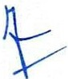

|  |  |  |
| --- | --- | --- |
| I | -q lcNI- g,t=i'lcfl -<IGP-ll•f CR 3TTt1<ITT 'cfR'ffT *t*  WELCOME TO DELHI-VADODARA-MUMBAI EXPRESSWAY | -r |

|  |  |  |
| --- | --- | --- |
| I | 'c.l q I G , g;:r: 3TT1lcfTT 3JTlTlFf *t*  THANK YOU, KINDLY VISIT AGAIN | -r |

|  |
| --- |
| Fig 3.6 Rumble Strip |
| Informatory Sign Board |
| **••®i=C•li**  1sf **30t 440t**  PADRA VADODARA MUMBAI  Fig 4.1 Reassurance Sign |
| ' '  -  Fig 4.2 Welcome Gantry |
| ' "  Fig 4.3 Thank You Gantry |
| Fig 4.4 Advance Direction Sign 2 km before Exit for Expressway |



|  |
| --- |
| Fig 4.5 Advance Direction Sign 1 km before Exit |
| Fig 4.6 Advance Direction Sign 500 m before Exit |
| Fig 4.7 Advance Direction Sign at Exit Nosing |
| , ,,,,  Fig 4.8 Advance Direction Sign at Exit Nosing of Cloverleaf |

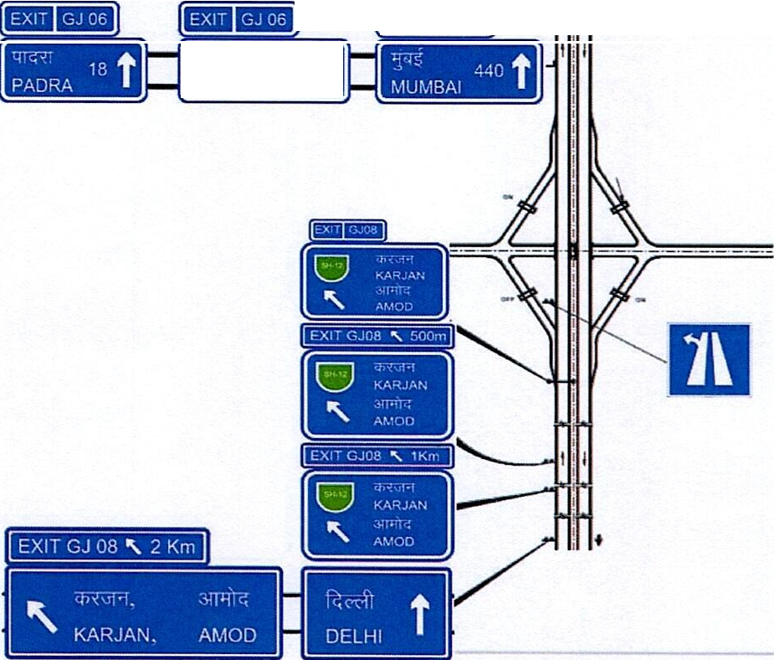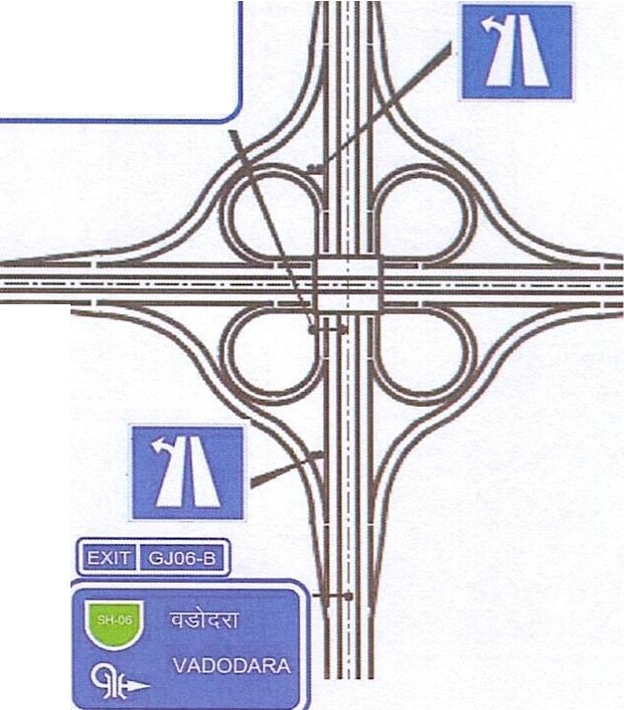

:,::·c:-;-; t30 VADODARA

--

Fig 4.9 Typical Advance Direction Sign arrangement at Diamond Interchange

(zJ

' VADODARA

<TTGxT

6

PADRA

'

Fig 4.10 Typical Advance Direction Sign arrangement at Nosing of Cloverleaf Interchange



rct-'>!fl=f 3frx rcn *e--n*

REST AND SERVICE AREA

**ii**

|  |
| --- |
| REST AND SERVICE AREA  **'iii , 11**  500mlii 1Km **Iii**  REST AND SERVICE AREA  **, ii ' i**  2Km **i i** 5Km **Iii** ...  Fig 4.11Rest And Service Area |
| Fig 4.12 Rest And Service Area at Exit Nosing |
| Fig 4.13 Emergency Helpline Number |
| ***O_@***  **c:Jlt;"i**  **3ITT61 1**  **Heavy Vehicle**  **Keep Left**  Fig 4.14 Heavy Vehicle Keep Left |

***r.li#FiiV***------

--

|  |  |
| --- | --- |
| Fig 4.15 Expressway and Expressway End Symbol | |
| Fig 4.16 Expressway Exit and Entry Ramp | |
| **500m**  Fig 4.17 Emergency Call Box | |
| ***,*** -- **t**-  **FEE PLAZA AHEAD**  Fig 4.18 Fee Plaza Ahead | |
|  |  |



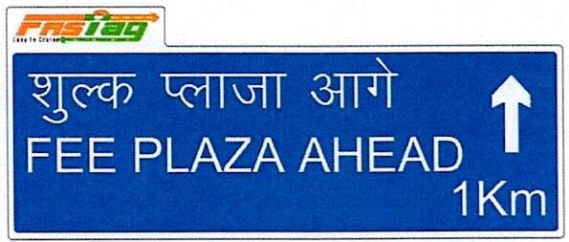

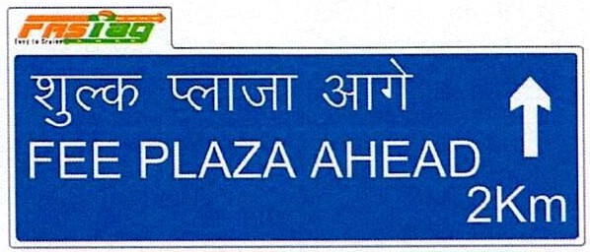

Fig 4.19 Fee Plaza

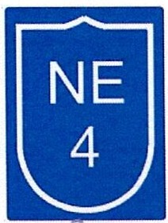

Fig 4.20 Route Marker

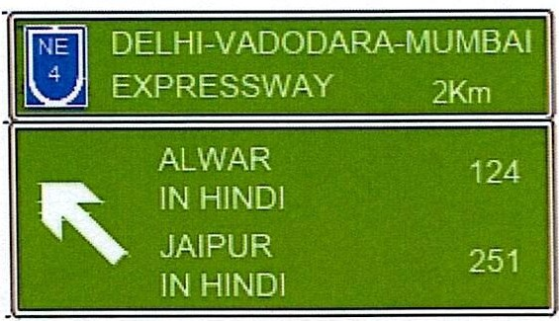

**IFif1**

### DELHI-VADODARA-MUMBAI EXPRESSWAY 1Km

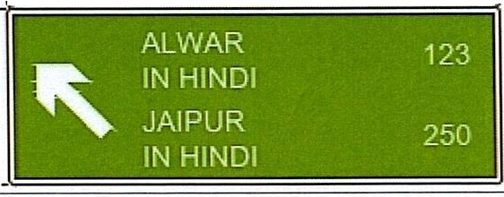



---:,---

-

---

**INCAR**

---

---

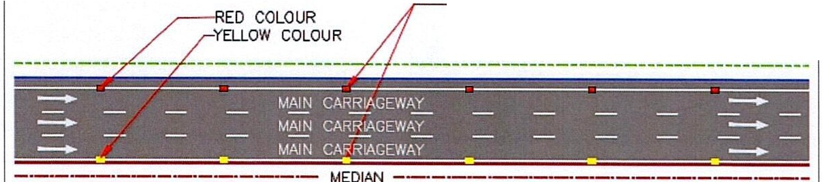

=================

fNE"l DELHI-VADODARA-MUMBAI

\ .) EXPRESSWAY 500m

Fig 4.21 Cross-Road Sign board

SERVICE ROAD

--=-

**P**•

**Iii**

**H1CE\'/AY**

_

Fig 5.1 Chevron Marking

MEDIAN ,=,:=i.>

LENGTH OF NORMAL FROM THE START

TO END. SPACING-18m

-

=

---

Fig 5.2 Road Stud at Normal Section

RED COLOUR

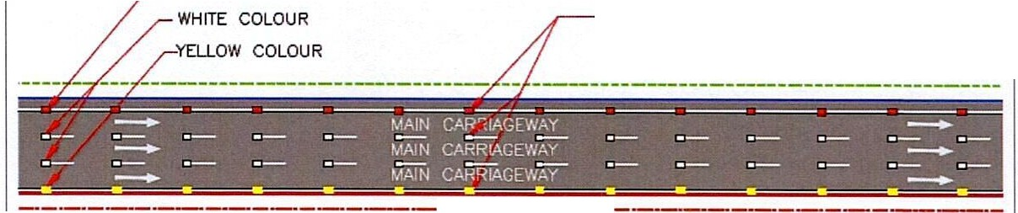

LENGTH OF WARNING FROM THE START

TO END. SPACING-9m

MEDIAN--·

Fig 5.3 Road Stud at Warning Section



|  |
| --- |
| UNI-DIRECTIONAL GREEN ROAD STUD FOR CROSSABLE CONTINUllY  LINE FOR ACCELERATION / DECELERATION LANE |

Fig 5.4 Road Stud at Merging/Diverging location

- -

---

-----

- ---------- -

---

----

--

--------

--- -

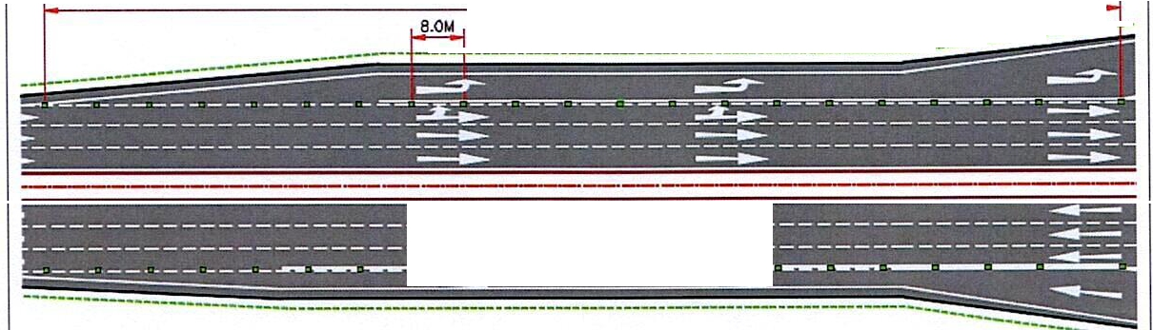

.,_._.

_....,

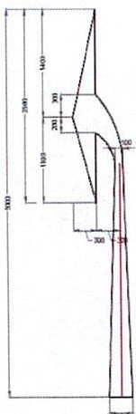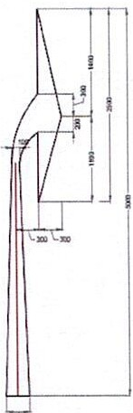

**A**-**M09 A**-**M1D**

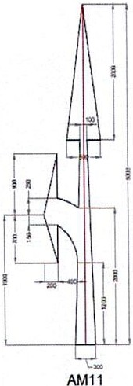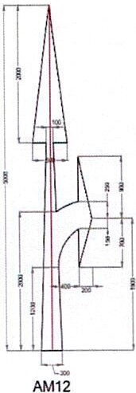 Fig 5.5 Direction Arrows

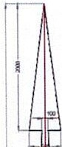

**AMOS**

..

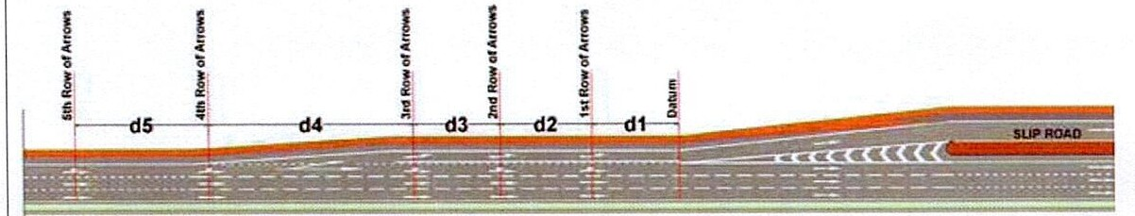

Fig 5.6 Direction Arrow distance at Entry and Exit Location



**18.Sm 5.Sm**

**32m**

Fig 5.7 Bifurcation Arrows

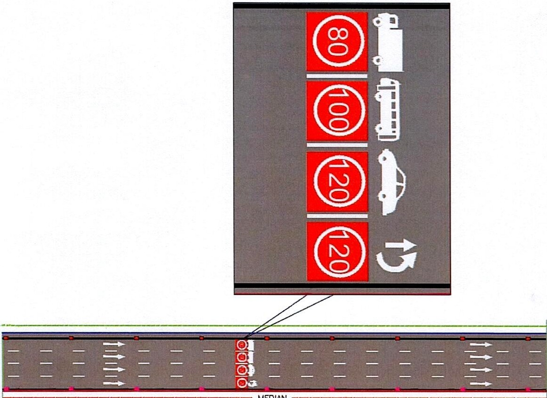

= - =•**t**o**o**

***c***

- - - - *.;:::_* - - -

**o*o***

==

==

**t*-***

- - -

_

- - - - -

-

======

=

=

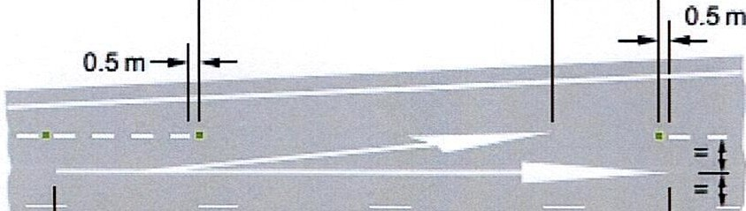

Fig 5.8 Speed Limit as Road Marking

### Appendix-8

(Letter No. RT-25035/07 /2023-RS(Part) dated *ZJ.?*July, 2023)

**Guidelines for provision of signages for National Highways**

## General

To maintain value added services, signs should be used to provide guidance, warnings, notice and regulatory information to road in well-designed formats for ensuring comfortable, safe and smooth driving.

Signs provide information on entry/exit directions, destinations and points of interest. Signs are designed so that they are legible to road users approaching them and readable in time to permit proper responses. Desired design characteristics include:

* Long visibility distances,
* Large lettering and symbols, and
* Short legends for quick comprehension

In general, the road signage shall follow IRC: 67 Code of practice for road signs, IRC: 35 Code of Practice for Road Markings and Clause 800: traffic signs, markings and other appurtenances in MORTH - Specifications for road and bridge works. In addition, now certain provisions are included in this guideline for better visibility and understanding of the road users on National Highways which shall supersede all CodaI provisions/guidelines issued till date in respect of these provisions and must be followed in addition to all other provisions of IRC: 67, IRC: 35 and Clause 800 etc.

Functionally road signages are classified as follows:

* Mandatory/Regulatory signs
* Cautionary/Warning signs
* Informatory/Guide signs

## Mandatory/ Regulatory Signs

These signs are used to impose legal restrictions applicable to particular locations and unenforceable without such signs. These include all signs, such as, Speed Limits, No Entry, etc. which give notice of special obligations, prohibitions or restrictions for traffic control. The violation of the rules and regulations conveyed by these signs is a legal offence and shall attract penalty.

#### Size and Dimension of Mandatory Signs

*Table 1: Size and Dimension of Mandatory Sign*

|  |  |  |  |
| --- | --- | --- | --- |
| Design Speed | Diameter (mm) | Border (mm) | Oblique Bar (mm) |
| Upto 65 kmph | 750 | 60 | 60 |
| 66-80 kmph | 900 | 70 | 70 |
| 81-100 kmph | 1200 | 100 | 100 |

*Oblique Bar will come to indicate in prohibition

#### Mandatory Signs to be installed

* + 1. No Parking

No Parking sign is used to prevent any parking of vehicles on the main carriageway which will lead to congestion. It is to be provided at an interval of every 5 km **(Fig. 2.1)**

* + 1. Speed Limit Sign Board

Speed limit sign board is provided to warn the drivers about the maximum speed limit at which they can drive their vehicle. Since the speed limit is different for car, bus and trucks the sign board **(Fig. 2.2)** and gantry **(Fig. 2.3)** has been introduced. Where different speed limits are to be imposed on certain classes of vehicle types this shall be specified separately to ensure that the numerals indicating the speed limit are clearly visible from a distance. Symbol of specific vehicle type shall accompany such speed limit indication **(Fig. 2.2).** The speed limit sign Board should be repeated at every 5 km alternately on shoulder side and median side. The size of sign board shall be 1800 X 3000mm in which the diameter of circle shall be as per Table-1.

* + 1. Speed Gantry:

Vehicle Category wise and speed wise lane dedicated information signs is to be installed on high-speed corridors at an interval of 20kms as an overhead gantry **(Fig. 2.3).**

* + 1. Height Limit Sign Board:

If the height of superstructure over bridges/underpass structures exceeds 5.Sm no board is required, but if it is less than 5.Sm then Height Limit Sign board of appropriate limit is to be provided **(Fig. 2.4).**

# Cautionary/ Warning Signs

These signs are used to call attention to actual or potentially hazardous conditions, so that the users can become cautious and take the desired action.

The signs shall be in the shape of an equilateral triangle, with apex pointing upwards. It shall have red border,and black symbols on white background.

#### Size and Dimension of Cautionary Signs

The size and siting details shall be as per Table 3.1.

*Table 2: Size and Dimension of Cautionary Sign*

|  |  |  |  |
| --- | --- | --- | --- |
| Design Speed | Diameter (mm) | Border (mm) | Distance of Sign from Hazard (mm) |
| Upto 65 kmph | 750 | 60 | 45-110 |
| 66-80 kmph | 900 | 70 | 110-180 |
| 81-120 kmph | 1200 | 90 | 180-245 |

#### Cautionary Sign to be installed

* + 1. Left-Hand and Right-Hand Curve

If the difference between the approach speed to a curve and the safe negotiating speed derived based on geometric parameters of curve exceeds 15 Kmph, the curve shall be provided with Left-hand curve and Right-hand curve warning sign boards. **(Fig. 3.1)**

* + 1. Merging Traffic Ahead

This sign is posted in situations where the traffic from other road/ entry ramps is merging with the traffic of main carriageway, and the drivers are required to slow down their vehicles for safe travel **(Fig. 3.2).**

* + 1. Overhead Cables

This sign is used to caution the driver of the presence of overhead power transmission lines **(Fig. 3.3).**

* + 1. Pedestrian Crossing

The sign should be erected in advance on both approaches to uncontrolled pedestrian crossings **(Fig. 3.4).**

* + 1. Reduced **Carriageway**

This sign is used to caution the driver of the reduction in the width of the carriageway ahead **(Fig. 3.5).**

* + 1. Rumble Strip

The sign should be posted at a minimum distance of 50to 60min advance of therumblestrips provided on the road to control and reduce the speed. This is to warn the drivers of the

presence of the rumble strips**(Fig. 3.6).**

# Informatory Signs

These signs are used to provide directions to motorists, including route designations, destinations, available services, points of interest, and other geographic, recreational, or cultural sites. These also inform drivers of traffic regulations and information on the points necessary for traffic operation.

#### Size and Dimension of Informatory Signs

|  |  |  |  |  |  |
| --- | --- | --- | --- | --- | --- |
|  | Overhead Direction Signs | | Shoulder Mounted  Direction Signs | |  |
| Design Speed | Text Height Lower Case  (mm) | Text Height Upper Case  (mm) | Text Height Lower Case  (mm) | Text Height Upper Case  (mm) | Text Thickness (mm) |
| Upto 65 | 240 | 340 | 140 | 195 | 50 -Lower Case  60- Upper Case |
| 66-80 | 200 | 280 |
| 81-100 | 280 | 390 | 245 | 345 |
| 101-120 | 330 | 460 | 245 | 345 |

*Font Type: Transport Medium

#### Informative Sign to be Installed

* + 1. Reassurance Sign

This sign is installed to reassure a driver of a vehicle that the desired direction is being followed. However, according to IRC:67 this sign is shoulder mounted but for better visibility it is converted to full Overhead Gantry **(Fig. 4.1).**

* + - * To be provided after 150-200m of Entry Slip and repeated after every 10 km in case the next entry is more than 10 km away
      * The first two destinations shall be the next two exit and the last shall be the ultimate destination
      * The distance of location mentioned on sign board should be the distance of the railway station of that location from the board
      * Every alternate or 20th km Reassurance Sign shall be in English and Regional/local language wherever applicable
      * Exit Number should be Exit-1, Exit-2, ...
    1. Welcome and Thank-You Gantry

Welcome and Thank You sign board should be installed in first and last package of the project to ensure the road user about the start of expressway so that the restrictions pertaining the project are being followed (Fig. 4.2 and Fig. 4.3).

* + 1. Advance Direction Sign

Advance Direction signs shall be used for grade separated Entry and Exit to the Access Controlled National Highway. These signs should be placed normally at 500 m, 1 km and at 2 km in advance of the exit. As per IRC:67 the Advance Direction Sign can be gantry or shoulder mounted. For better visibility at high speed, a full overhead gantry shall be provided for Advance Direction Sign Board placed at 2 km before exit **(Fig. 4.4)** and cantilever gantry for Advance Direction Sign Board shall be placed at 500 m and 1 km before exit and at tapering of Exit Ramp. Also, the Cantilever Gantry at 1km before exit should be in Regional and English Language **(Fig. 4.5, Fig. 4.6 and Fig. 4.7).** Typical Exit arrangement is shown in **Fig. 4.8.**

* + 1. Rest and Service Area Sign Board

This sign board is to be provided to inform the road user about the upcoming Way­ Side amenity. It is necessary to alert the driver about the existence of way side amenities by providing cantilever gantry type sign board 2 km ahead with repeater sign at 1 km and 500 m ahead and flag type shoulder mounted sign board at the exit nosing for way side amenity. Also, the Rest and Service Area sign board 1 km before

the wayside amenity should be in Hindi i.e., fcl°3fll1 '3flx 00 and at 2 km before

wayside amenity it should in regional language. The dimension of facility sign (logo)

fy



shall be 1200 X 900 mm and dimension of sign board shall be 4100 X 3000 mm. The Text height should be 460mm. **(Fig. 4.9 and Fig. 4.10).**

* + 1. Emergency Helpline Number

The Emergency Helpline number "1033" should be provided at every 5km interval dimension 2400 X 1800 mm **(Fig. 4.11).**

* + 1. Heavy Vehicle Keep Left

This sign board is to be provided to inform the drivers of heavy vehicles like trucks moving at lesser speed to drive on left side so that the vehicles moving at higher speed can easily overtake them. The sign board should be provided at an interval of 5 km. dimension 2400 X 2400 mm **(Fig. 4.12).**

* + 1. Emergency Call Box

This sign shall be used at regular intervals in rural highways and in tunnel roads where emergency phones are installed. Sign Board should be installed 500m ahead of Emergency Call Box. Dimension 600 X 900 mm **(Fig. 4.13).**

* + 1. Fee Plaza:

If the project is following closed tolling system, then Fee Plaza Ahead sign board should be provided on slip road **(Fig. 4.14),** no sign regarding fee plaza should be displayed on main carriageway, where fee plaza in on slip road. In case if the fee plaza is on main carriageway, it is necessary to alert the driver about the existence of fee plaza by providing cantilever gantry type sign board 2 km ahead with repeater sign at 1 km and 500 m ahead **(Fig. 4.15).**

* + 1. Route Marker

Route Marker sign should be provided at every 5km interval. Dimension 600 X 800 mm (Fig.

**4.16).**

1. Road Markings

#### Diagonal and Chevron Marking

Channelizing markings like diagonal and chevron markings are utilized to demarcate the neutral area at the nose of a channelizing island for reducing the incidence of collision with kerb nose. Red coloured Road studs should be provided at spacing of 2m/4m/6m for better visibility at night and adverse weather condition. They direct the entering and exiting traffic into the proper angle for smooth movements of divergence and convergence. These markings provide for proper and safe use of acceleration and deceleration lanes **(Fig. 5.1).**

#### Road Studs

Retro-reflective studs are used to supplement longitudinal/transverse reflectorized road markings, which would improve visibility in night-time and adverse weather conditions. Road studsare also used across the carriageway to serve as Speed Arrestor coupled with eschewing warning through the creation of the rumbling sensation to the user. Series of such road reflector studs are to be laid in advance of

junction/crossings/end of the flyover section wherein road crashes are prevalent. Different coloured road studs are used at different location{Fig. **5.2, Fig. 5.3 and Fig.5.4).**

* + 1. Colour for Road Studs

The studs with different colours of reflectors such as white, red, yellow and green are used for highways. The usage of different colours of studs is as follows.

* + - 1. *Red Colour*

Red road studs are to be used to indicate a line which should not be crossed and mainly to delineate left hand edge of the running carriageway i.e., for road studs to be used on shoulder side edge line. The road studs shall be omitted or can be replaced with green colour where the facility for exiting traffic is provided from the main carriageway like entry to Truck Lay Bye/Bus Bay, Start of Service Road, etc.

* + - 1. *Yellow Colour*

Yellow road studs are to be again deployed to indicate a line which should not be crossed with the aim to delineate the right-hand edge of the running carriageway in case of the multi-lane divided carriageways i.e., median side edge line.

* + - 1. *White Colour*

White road studs are to indicate traffic lane line and centre of carriageway. Mainly used at warning sections.

* + - 1. *Green Colour*

Green road studs are to be employed to indicate crossable edge line like the lay byes and to show the boundary of acceleration or deceleration line on left hand side of the carriageway in case of the multi-lane divided carriageways.

* 1. Direction Arrow Markings

Directional arrows should be used in advance to guide drivers to correct lane when approaching busy intersections whether signal controlled or not. Directional arrows must be elongated in the direction of the traffic flow to have adequate legibility, as arrows are viewed at low angle **{Fig. 5.5).** The length of directional arrow is as per speed is shown in table below:

|  |  |
| --- | --- |
| Speed | Length of Arrows |
| Upto 50 kmph | 3.Sm |
| 51-100 kmph | Sm |
| > 100 kmph or Expressway | 9m |

The direction arrow near Entry and Exit location **(Fig. 5.6)** should be as per table below:

|  |  |  |  |  |  |
| --- | --- | --- | --- | --- | --- |
| Approach Speed | D1 | D2 | D3 | D4 | D5 |
| 81-100 kmph | 30 | 45 | 90 | 180 | - |
| >lO0kmph | 30 | 60 | 90 | 150 | 150 |

Other than Entry and Exit location the straight arrow should be repeated at every 10 km

#### Bifurcation Arrow

The bifurcation arrow should be provided at the commencement of deceleration lanes on the approach to junctions to guide vehicles ensuring that the full length of the lane is used to slow down for the junction without impeding the through vehicles on the main carriageway **{Fig. 5.7).** The size of bifurcation arrow is prescribed in table below:

|  |  |
| --- | --- |
| Speed | Length of Arrows |
| < 65 kmph | 8m |
| 65-100 kmph | 16m |
| > 100 kmph or Expressway | 32m |

#### Speed Limit as Road Marking

Speed limit along with vehicle logo should be marked on the pavement to guide the road user about the appropriate driving speed and lane **(Fig. 5.8).** This marking should be repeated at every 10 kms. The text height of the marking is prescribed in table below:

|  |  |
| --- | --- |
| Speed | Text Height |
| <50 kmph | 1.2m |
| >50 kmph | 2.Sm |





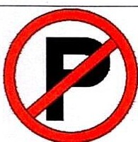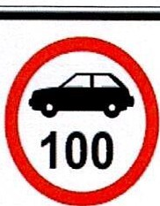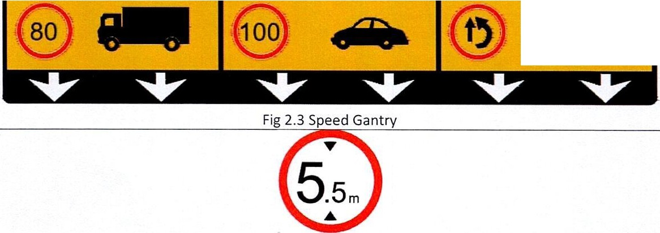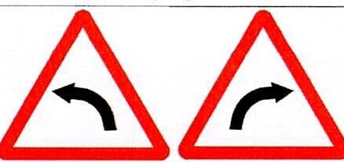

**MANDATORY SIGN BOARD**

Fig 2.1 No Parking

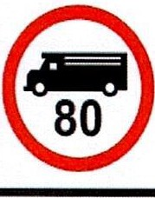

Fig 2.2 Speed Limit

**Overtaking Lane**

Fig 2.4 Height Limit Cautionary Signs Boards

Fig 3.1 Left-Hand and Right-Hand Curve

Fig 3.2 Merging Traffic Ahead

Fig 3.3 Overhead Cables

Fig 3.5 Reduced Carriageway

Fig 3.6 Rumble Strip Informatory Sign Board

**•f:iiB ·•++UH**

**t**

**•Iii•**

* 20

Rewari

Narnaul 30 **t**

Ambala

72 **t**

Fig 4.1 Reassurance Sign

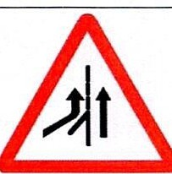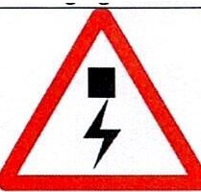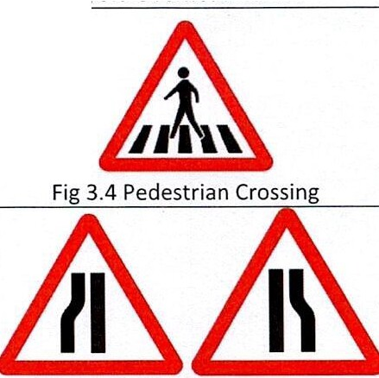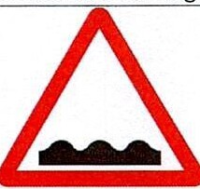

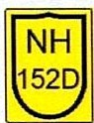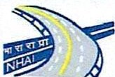**IN HINDI**

**WELCOME TO TRANS-HARYANA**

Fig 4.2 Welcome Gantry

**IN HINDI**

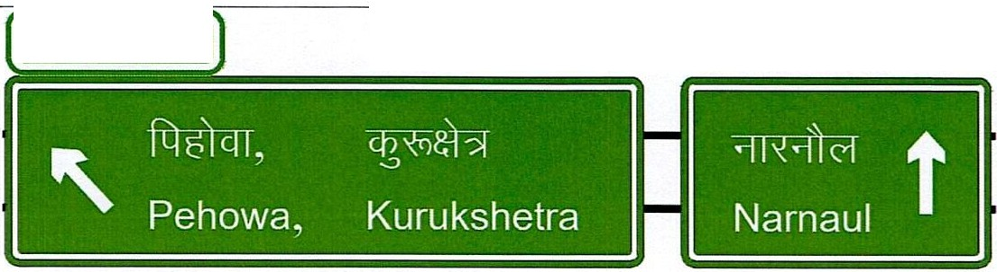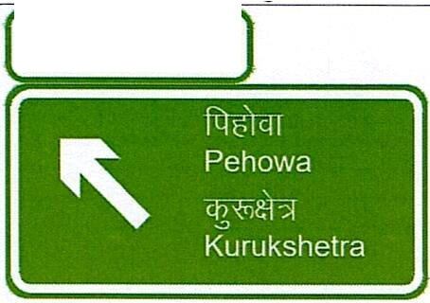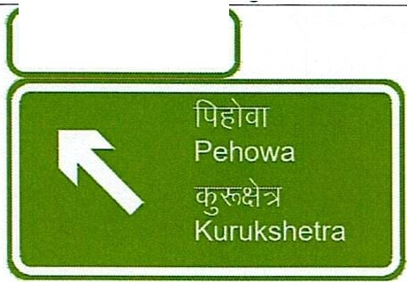

*ih*

**THANK YOU, KINDLY VISIT AGAIN**

Fig 4.3 Thank You Gantry

EXIT2 '\ 2 Km

Fig 4.4 Advance Direction Sign 2 km before Exit

#### EXIT 2 1 Km

Fig 4.5 Advance Direction Sign 1 km before Exit

#### EXIT 2 500m

Fig 4.6 Advance Direction Sign 500 m before Exit

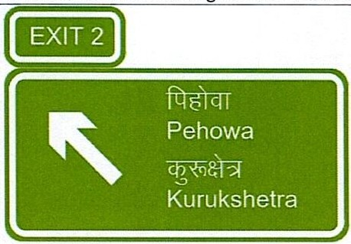

Fig 4.7 Advance Direction Sign at Exit Tapering



**1¥1£Htfl:@**

# It:

*n&.r* ,1

Pehow.1 I

, iJJ °'-:r; I

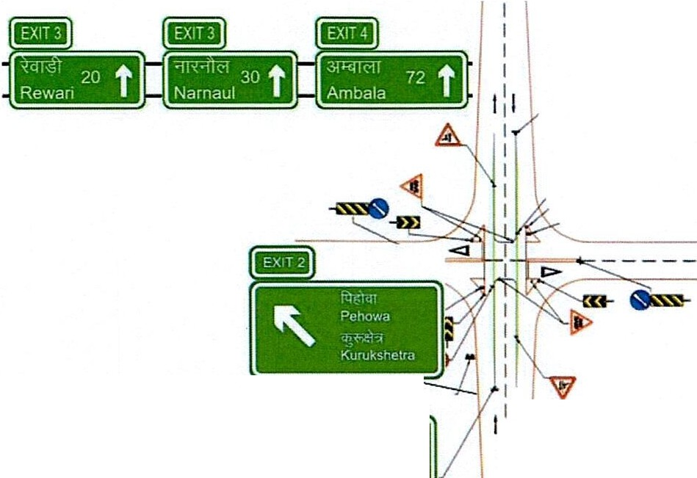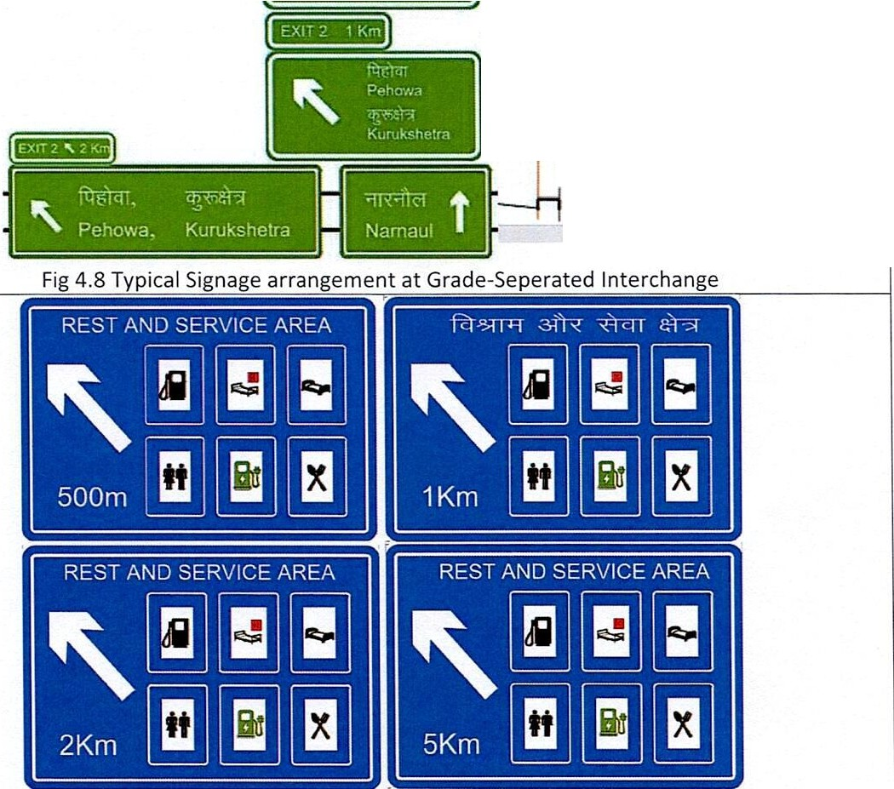

Kurukshetra I

--

I I I I I I I

I

*i*

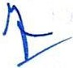 Fig 4.9 Rest And Service Area

Fig 4.11Emergency Helpline Number

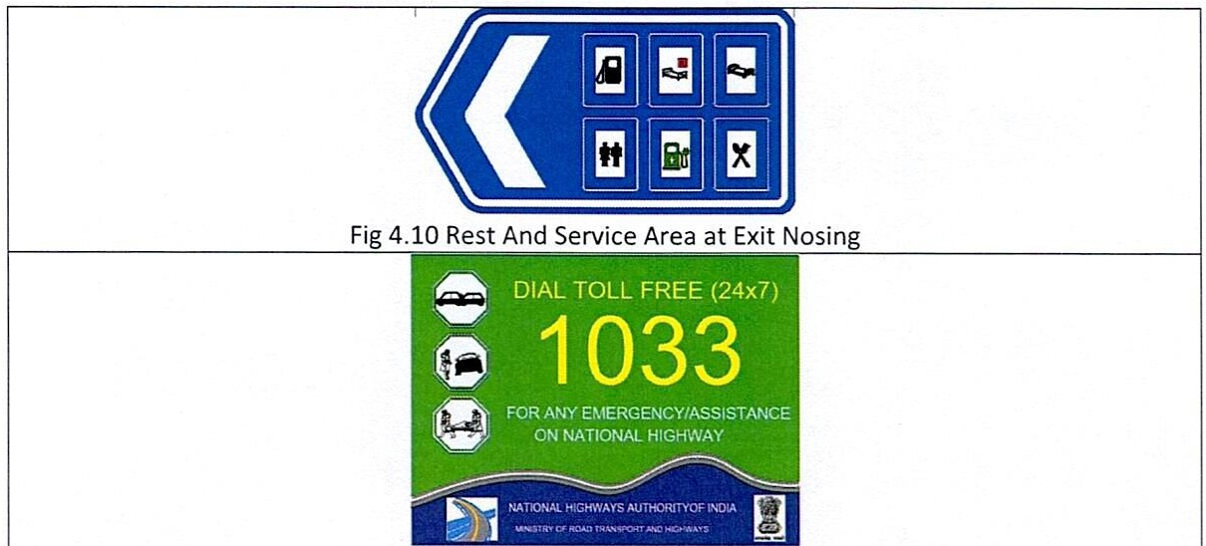

**500m**

I

**Heavy Vehicle**

**Keep Left**

3ITT° **61**

**G@**

**ql5.=t**

Fig 4.12 Heavy Vehicle Keep Left

Fig 4.13 Emergency Call Box

**t**

3illT

**FEE PLAZA AHEAD**

Fig 4.14 Fee Plaza Ahead

Fig 4.15 Fee Plaza

**NH**

**344P**

Fig 4.16 Route Marker

·= - _ _ _ _ _ _

-=-

--

--

-

SERVICE ROAD

**N CAHRIGE.WAY** _

--

**--.,.**

--

--**W**

MEDIAN ::::?

**ut-**Fig **a**5.1 C**-**hevr**-**on M**-**arkin**i**g **•**

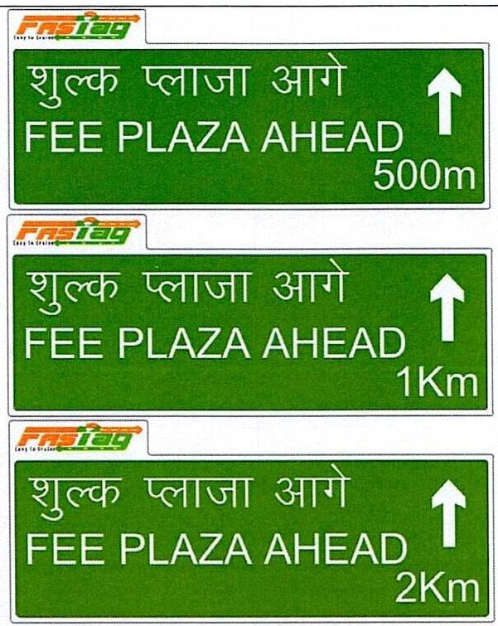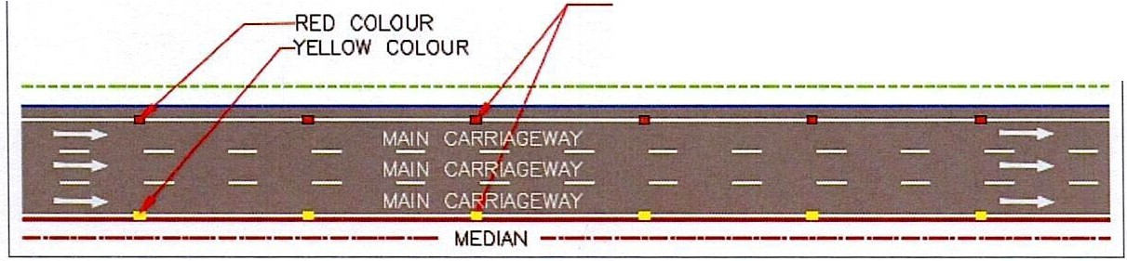

LENGTH OF NORMAL FROM THE START

TO END. SPACING-18m

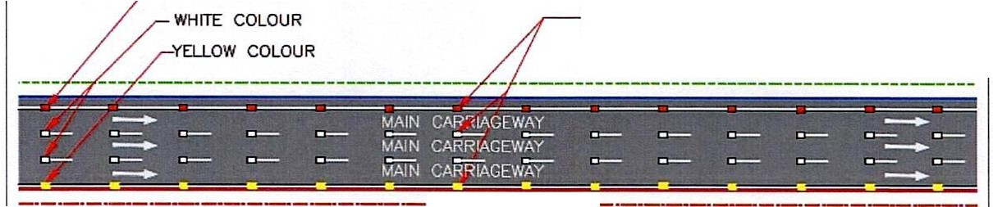

Fig 5.2 Road Stud at Normal Section

RED COLOUR

LENGTH OF WARNING FROM THE START

TO END. SPACING-9m

MEDIAN ---·

Fig 5.3 Road Stud at Warning Section

UNI-DIRECTIONAL GREEN ROAD STUD FOR CROSSABLE CONTINUITY LINE FOR ACCElfRATION / DECELERATION LANE

-

--

----

----

-

--

,,

-

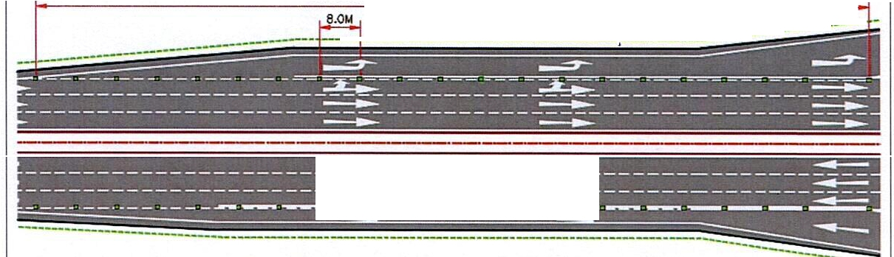

- '

,

-

-

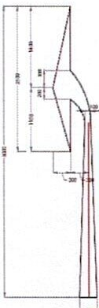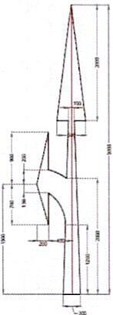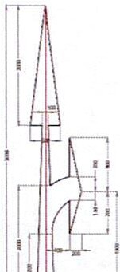 Fig 5.4 Road Stud at Merging/Diverging location

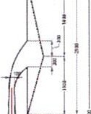

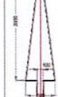

'-• -

AM08

AM'-09 AM1-0

Fig 5.5 Direction Arrows

AM11

L_-_

AM12

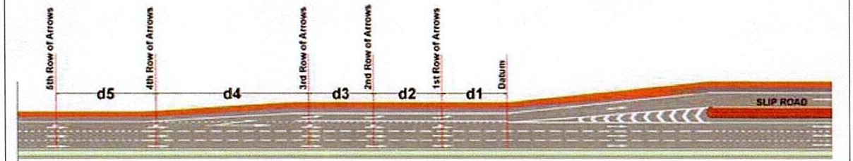

Fig 5.6 Direction Arrow distance at Entry and Exit Location

|  |
| --- |
| **32m** |

Fig 5.8 Speed Limit as Road Marking

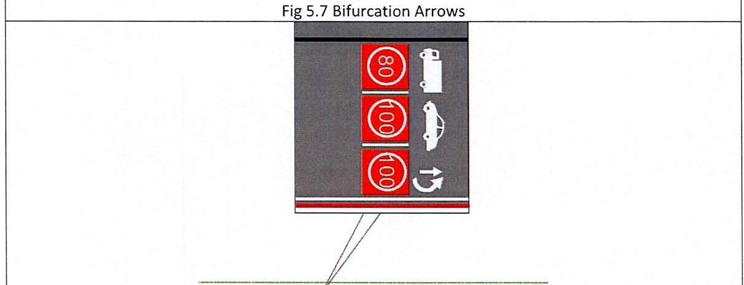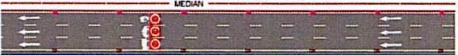

77 _ _ _ **Ql** _ _ _ _ _ _ *..=-* _ _

-

77 _ _ _ **01** _ _ _ _ _ _ *..=-* _

=-

